Mehmet Izol

Professor Cleveland

COMP 3324-1 Computer Networks

Week 5 – Lab 1 – Web Goat

February, 28, 2023

Web Goat

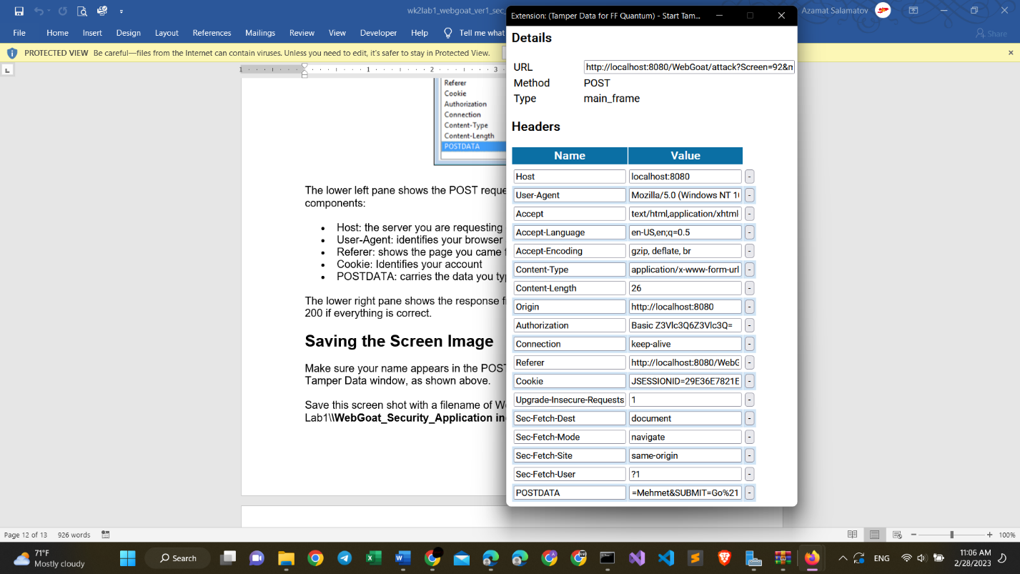

What new I learned

+ tamper data recorded my data when I was working with Web goat.

+ The new version of tamper was different from the tamper on the lab guide.

+ tomcat application also was changing while I was working on webgoat site.